**Udan Khatola **

**Phir se udd Chala**

So basically our team (hackerman) has submitted our project in the track web design.

We have created a website for flight booking named Udan Khatola.

Users can log in to the website and book a flight ticket.

As it doesn’t contain a back-end we have chosen that the user is booking a flight from Bangalore to Bombay.

We have implemented 6 web pages:- Home Page, login page, flight booking page, list of flight page, payment gateway page, and about us page.

We have a common navbar and footer page for all our websites.

1. Home page- It shows the features of our website, we have implemented it using carousels and sliders .
2. Login page- It’s a normal Login page.
3. Flight booking page- As it doesn’t have backend the page doesn’t do much, for any info you enter, it will be redirected to a webpage showing Flights from BLR to BOM.
4. List of flight page- Shows the number of flights from BLR to BOM , popular filters are there, and a book button.

For example- the book button of the first flight works clicking on it we will be redirected to the payment gateway.

1. Payment gateway page-It takes user payment info and book the fight for them
2. About us page- It contains the info about the company

And the contact us button opens a dialogue box with which users can send their query and ask our company.

Navbar- Our site’s nav bar contains our site name which is a hyperlink to the homepage, home button also for the same, about us button which is hyperlinked to a new webpage, contact us button which slides down to the footer of our page. A login button redirects to the login page.

Footer- footer contains the contact details of our company and various hyperlinks which are not working as there is no back end.

We also faced various problems such as white spaces being created on their own for no reason but bhaiya helped us for that, for other problems such as in JavaScript-MDN docs, StackOverflow helped a lot.

Rest we discussed with other teams to solve the problem.

Working of our website:

We also used javaScript to implement Alert boxes.

But there is a problem in the Alert boxes :

The “Onclick” function works only one time for a button

So we implemented “onpress” on the home page and on the payment gateway explained in the video.

We have also created the Figma design link and screenshot as follows:

<https://www.figma.com/file/DJWFDl0jHpuErGz0EBJGby/BookYourUdaan?node-id=30%3A444>

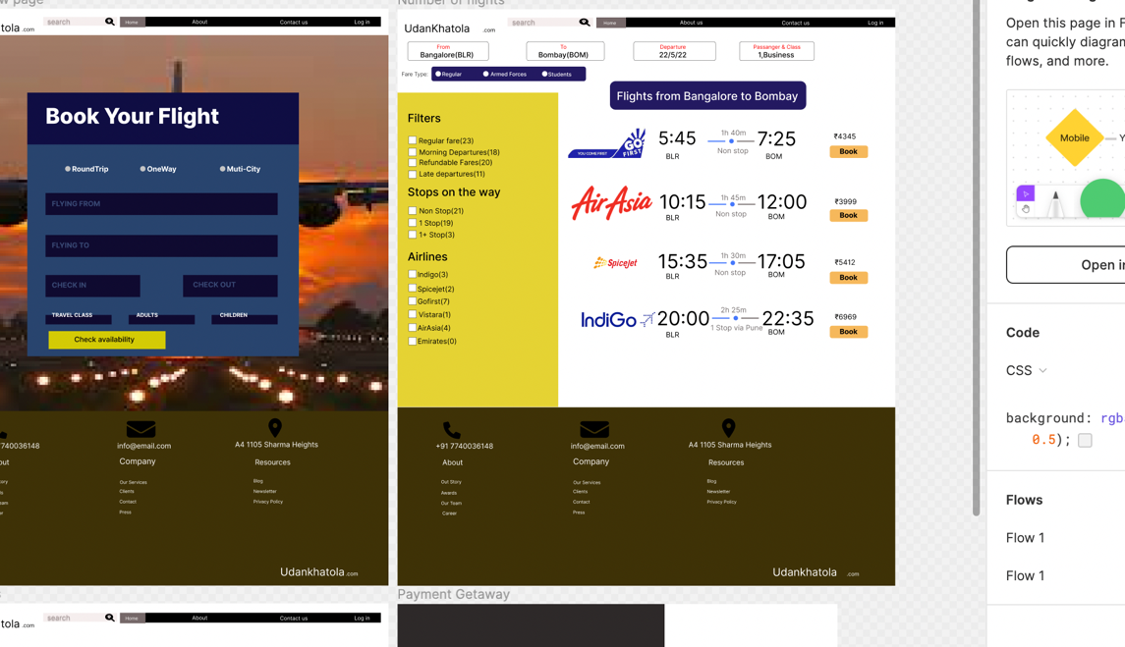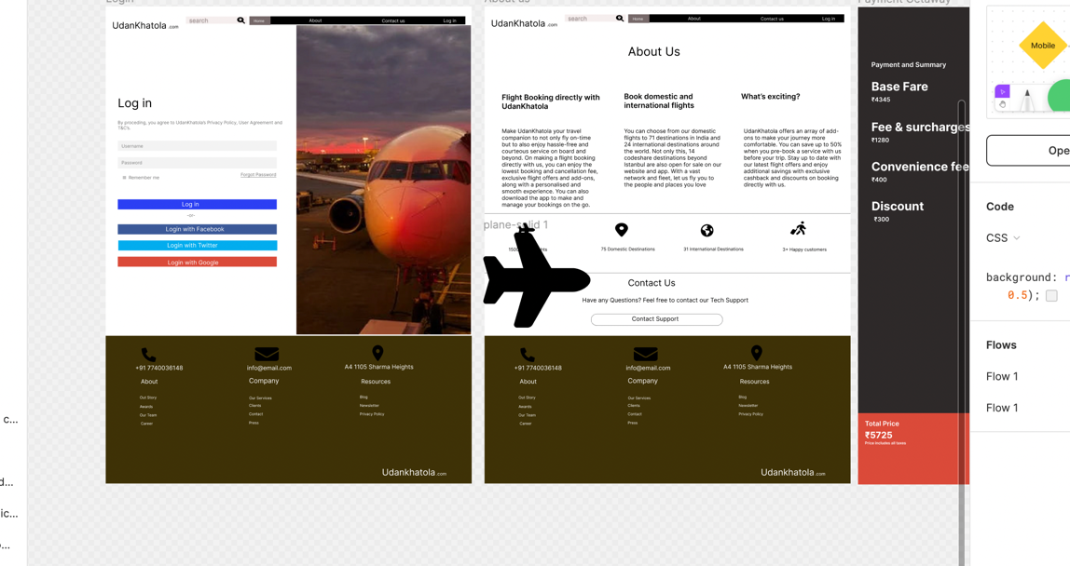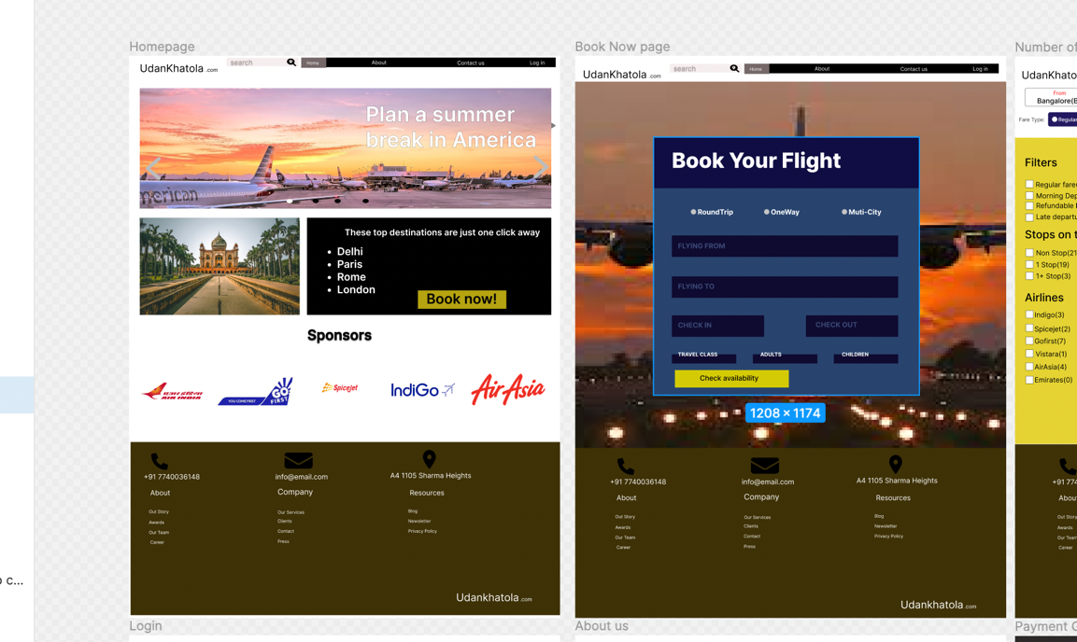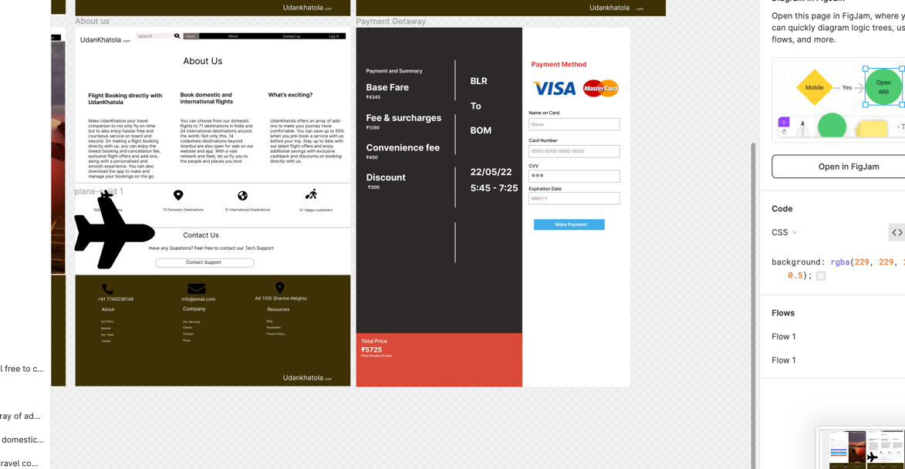

The alert boxes some on

